THE NAME OF THE FIRST AUTHOR (Times New Roman, Capital Letters, 10 pt, centred)
e-mail address, which will be published in the publication (Times New Roman, 8 pt, centred)
Affiliation that contains the address of institution represented by the author (Times New Roman, 8 pt, centred)
ORCID ID: https://orcid.org/0000-0000-0000-0000 (Times New Roman, 8 pt, centred)

THE NAME OF THE SECOND AUTHOR (Times New Roman, Capital letters, 10 pt, centred)
e-mail address, which will be published in the publication (Times New Roman, 8 pt, centred)
Affiliation that contains the address of institution represented by the author (Times New Roman, 8 pt, centred)
ORCID ID: https://orcid.org/0000-0000-0000-0000 (Times New Roman, 8 pt, centred)

(should be repeated for more than two authors)

Title of the paper (Times New Roman, 12 pt, italics, centred)

Keywords: (at least 3 to max 5 words or phrases; Times New Roman, 8 pt, left-aligned, words separated with semicolon)
JEL: (at least 3 to max 5 detailed categories; Times New Roman, 8 pt, left-aligned, words separated with semicolon, available at: http://www.aeaweb.org/jel/jel_class_system.php#A)

How to quote this paper: Author, A., Author, B., & Author, C. (YYYY). Title of the paper. Annales Universitatis Mariae Curie-Skłodowska, sectio H – Oeconomia, Vol. XYZ, No. (Times New Roman, 8 pt, left-aligned)

Abstract (from 200 up to 450 words; Times New Roman, 10 pt, justified; mandatory four aspects, as follows)

Theoretical background: Text.
Purpose of the article: Text.
Research methods: Text.
Main findings: Text.

(General requirement: abstract cannot be longer than one page).

(General remarks: The minimum length of the paper is 5 000 words with references, figures and tables. Shorter papers will not be transferred to the reviewing process. The maximum length of the paper is 8 000 words with references, figures and tables. The publication of the standard paper is free of charge. In the case of longer articles the author(s) are expected to cover publication fee, calculated proportionally to the additional length of the article or author(s) are expected to shorten the paper to the required length in question. The text has to be prepared in this type of format: Times New Roman, 12 pt, 1,5-spaced lines, justified, paragraph indent of the 1st line 1 cm, edges: right – 2,5 cm, left – 2,5 cm, upper – 2,5 cm, lower – 2,5 cm. The suggested scheme of article: the paper should be divided into following sections: Introduction, Literature review, Research methodology, Results, Discussions, Conclusions, References. It is suggested that explanation concerning individual arguments, should be set using bottom note, in this type of format: Times New Roman, 8 pt, fully justified, bottom note, continuous Arab numeration. The bottom notes should be limited to absolute minimum).

Title of the paper (Times New Roman, 12 pt, italics, centred)

Keywords: (at least 3 to max 5 words or phrases; Times New Roman, 8 pt, left-aligned, words separated with semicolon)
JEL: (at least 3 to max 5 detailed categories; Times New Roman, 8 pt, left-aligned, words separated with semicolon, available at: http://www.aeaweb.org/jel/jel_class_system.php#A)

Introduction (Times New Roman, 12 pt, bold 1,5-spaced lines, left-aligned)
The introductory part outlines shortly the objectives and motivation for writing the paper. The introduction should provide a theoretical context for the discussion in the body of the paper and point explicitly the purpose of the article.

Literature review (Times New Roman, 12 pt, bold 1,5-spaced lines, left-aligned)
The literature review shows who dealt with similar research topic before. The literature background shows what are the results of the prior studies. Additionally different options and perspectives from the literature should be identified and documented. The text should include necessary references.

Research methods (Times New Roman, 12 pt, bold 1,5-spaced lines, left-aligned)
This section is mandatory and it should provide specific description of the methodology. It should contain: the description of the research methods, description of the material selection, the hypotheses (at least one), strengths and weaknesses of the methodology.

Results (Times New Roman, 12 pt, bold 1,5-spaced lines, left-aligned)
The section results should presents an appropriate interpretation of the data in prospect of quoted references. Results should to be discussed in details, sound reasoning and present originality and a sort of novelty.

Discussions (Times New Roman, 12 pt, bold 1,5-spaced lines, left-aligned)
In this section the findings should be compared to findings of other authors. They should lead to assessment or critiques of the previous findings and/or the statistical analysis.

Conclusions (Times New Roman, 12 pt, bold 1,5-spaced lines, left-aligned)
This part should include the general summary of the article, its results and findings, implications and recommendations for practice, research limitations and suggestions for future research.

References (Times New Roman, 12 pt, bold 1,5-spaced lines, left-aligned)
(References to any material that has been provided by a previous authors, or been published in other sources should be set in harmonization with APA styles (American Psychological Association 7th edition – see more http://www.apastyle.org/ and https://www.usq.edu.au/library/referencing/apa-referencing-guide; Times New Roman, 10 pt, 1-spaced lines, justified, without numeration. Websites should not be formatted as hyperlink. As the publisher of the journal is a member of Crossreff and journal has DOI number the authors are obliged to prepare their references in a form that fulfil the criteria of the DOI system: http://www.crossref.org/guestquery/. If possible Author(s) should use references to literature in English, expect specific sources for the issue presented in the paper).

Examples of references:

Bernanke, B., & Boivin, J. (2010). Monetary policy in a data-rich environment. Journal of Monetary Economics, 50(3). doi: 10.1016/S0304-3932(03)00024-2.
Poon, S. H., & Granger, C. (2003). Forecasting volatility in financial markets: a review. Journal of Economic Literature, 19(1). doi: 10.1257/002205762743.

(Templates of tables and figures)

Table 1. (Times New Roman, bold, 10 pt, 1-spaced lines, fully justified) Name / description of the table (Times New Roman, without bold, 10 pt, fully justified)
Text of table (Times New Roman, 10 pt, fully justified, single-space line)
Source: (APA7 style, Times New Roman, 8 pt, left justified)

Figure – Times New Roman, 10 pt, exclusively in greyscale, justified, without frames
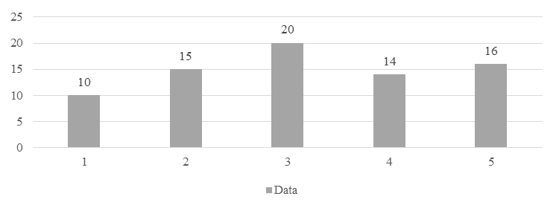
Figure 1. (Times New Roman, bold, 10 pt, 1-spaced lines, fully justified) Name / description of the figure (Times New Roman, without bold, 10 pt, fully justified)

Source: (APA7 style, Times New Roman, 8 pt, centred)

